Culturally Responsive Teaching and Leading Standards

Self-Awareness and Relationships to Others: Culturally responsive teachers and leaders are reflective and gain a deeper understanding of themselves and how they impact others, leading to more cohesive and productive student development as it relates to academic and social-emotional development for all students.

Systems of Oppression: Culturally responsive teachers and leaders understand that there are systems in our society especially, but not limited to, our school system, that create and reinforce inequities, thereby creating oppressive conditions. Educators work actively against these systems in their everyday roles in educational institutions.

Students as Individuals: Culturally responsive teachers and leaders view and value their students as individuals within the context of their families and communities.

Students as Co-Creator: Culturally responsive teachers and leaders who fundamentally believe all students are capable center learning around students’ experiences and position them as co-creators, with emphasis on prioritizing historically marginalized students.

Leveraging Student Advocacy: Culturally responsive teachers and leaders will support and create opportunities for student advocacy and representation in the content and classroom.

Family and Community Collaboration: Culturally responsive teachers and leaders will partner with families and communities to build rapport, form collaborative and mutual relationships, and engage in effective cross-cultural communication.

Content Selections in all Curricula: Culturally responsive teachers and leaders intentionally embrace student identities and prioritize representation in the curriculum. In turn, students are not only given a chance to identify with the curriculum, they become exposed to other cultures within their schools and both their local and global communities.

Student Representation in the Learning Environment: Culturally responsive teachers and leaders ensure the diversity of their student population is equally represented within the learning environment. In turn, all members of the student population feel seen, heard, and affirmed. Exceptionally well-versed culturally responsive teachers and leaders provide exposure to underrepresented or misrepresented minority groups, even when they are not present within the population of their school and community at large.

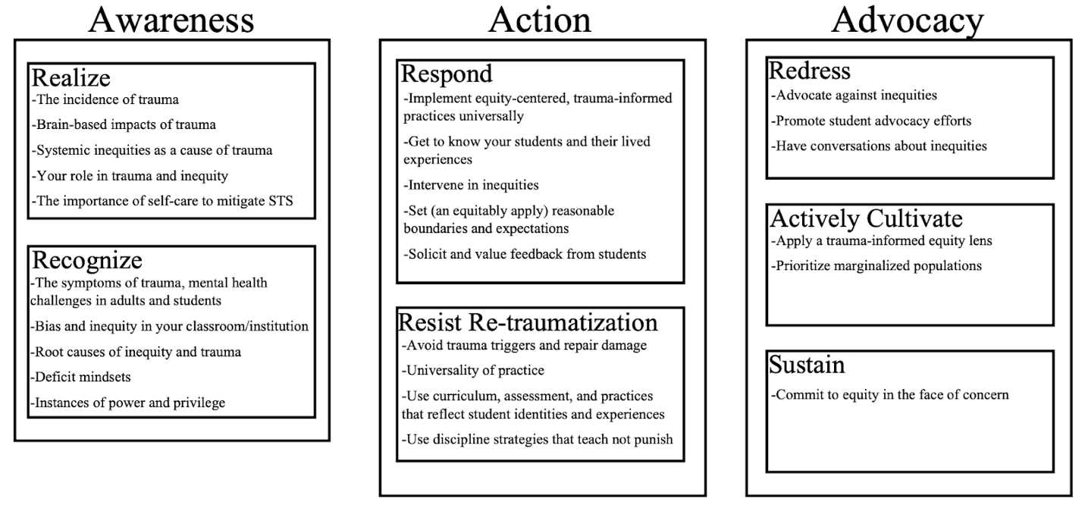Equity Literacy Framework: Equity Literacy Institute
SAMHSA 4 Rs/NCTSN: Trauma-Informed Schools-A Systems Framework
CRTL: Illinois Culturally Responsive Teaching and Leading Standards

PRECONFERENCE WORKSHEET

How does this lesson reflect the Culturally Responsive Teaching and Leading Standards? (1b, 1c)

What misconceptions do you anticipate and how will you proactively address them? (1b, 3a, 3c, 3d)

Have you identified any vocabulary/academic language that you need to explain? (1b, 3a, 3c, 3d)

Do you anticipate any academic or behavioral challenges? How will you proactively address them? How will you respond if issues arise? How are your strategies trauma-informed? (2b, 2c, 2d)

What planned supports will you use for whole class, small groups, individuals, and students with specific learning needs (IEPs and 504s)? (1b, 1c)

How will you actively engage your students? (3b, 3c)

What formative and/or summative assessments will help you monitor learning? (1f, 3d)

