Culturally Responsive Teaching and Leading Standards

Self-Awareness and Relationships to Others: Culturally responsive teachers and leaders are reflective and gain a deeper understanding of themselves and how they impact others, leading to more cohesive and productive student development as it relates to academic and social-emotional development for all students.

Systems of Oppression: Culturally responsive teachers and leaders understand that there are systems in our society especially, but not limited to, our school system, that create and reinforce inequities, thereby creating oppressive conditions. Educators work actively against these systems in their everyday roles in educational institutions.

Students as Individuals: Culturally responsive teachers and leaders view and value their students as individuals within the context of their families and communities.

Students as Co-Creator: Culturally responsive teachers and leaders who fundamentally believe all students are capable center learning around students’ experiences and position them as co-creators, with emphasis on prioritizing historically marginalized students.

Leveraging Student Advocacy: Culturally responsive teachers and leaders will support and create opportunities for student advocacy and representation in the content and classroom.

Family and Community Collaboration: Culturally responsive teachers and leaders will partner with families and communities to build rapport, form collaborative and mutual relationships, and engage in effective cross-cultural communication.

Content Selections in all Curricula: Culturally responsive teachers and leaders intentionally embrace student identities and prioritize representation in the curriculum. In turn, students are not only given a chance to identify with the curriculum, they become exposed to other cultures within their schools and both their local and global communities.

Student Representation in the Learning Environment: Culturally responsive teachers and leaders ensure the diversity of their student population is equally represented within the learning environment. In turn, all members of the student population feel seen, heard, and affirmed. Exceptionally well-versed culturally responsive teachers and leaders provide exposure to underrepresented or misrepresented minority groups, even when they are not present within the population of their school and community at large.

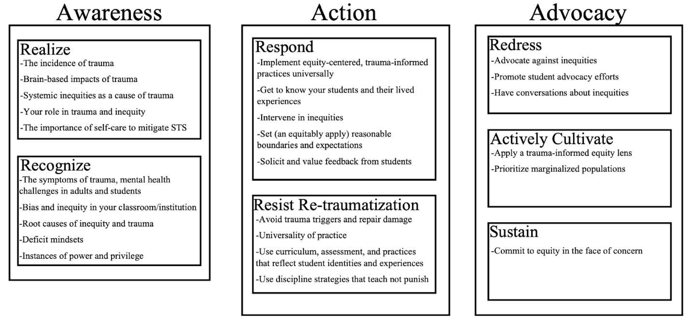Equity Literacy Framework: Equity Literacy Institute
SAMHSA 4 Rs/NCTSN: Trauma-Informed Schools-A Systems Framework
CRTL: Illinois Culturally Responsive Teaching and Leading Standards

POST-CONFERENCE WORKSHEET

Was this lesson successful? How do you know? (4a, 3d)

Which students were most engaged? How do you know? (4a, 3b, 3c)

Which students were least engaged? How do you know? What steps will you take to increase their engagement in future lessons? (4a, 3b, 3c)

What did you learn about your students while teaching this lesson? (1b)

Describe how your management was or was not effective, appropriate, and trauma-informed? What steps will you take in future lessons? (4a, 2b, 2c, 2d)

How did you assess progress for this lesson’s objectives? (3d, 4b)

What is the big take-away from this lesson? How will you apply what you learned to future teaching? (4a)

